Software Engineering and Testing Laboratory

Name: Neeraj Varma

Roll. No.: 08

PRN:1032210651

Assignment 1

Software Requirements Specification

* Aim: The aim of SRS is to specify the software product in details. In other words, it contains all necessary and important information that the product team should be aware of in order to create the software
* Problem Statement: To develop and implement an inventory management system that keeps track of the tools inventory of businesses and helps them monitor tools being rented or actively being used by issuing a checkout feature that lets the borrower keep track of the goods that they have responsibility for
* Purpose: The software will log tools that are added / rented to and from the business. It also has the added functionality of monitoring the individual who issues the said tools and to keep track of important return or purchase deadlines
* Product Description: The product will be a GUI with embedded front-end, python and will use SQL as its backend. Upon selecting the tools the user wants to borrow, the interface visualizes the cart of the items selected and once confirmed logs the following transaction in its database
* Product Requirements:

The software will have the following functional requirements:

1. User Authentication
2. Inventory System that allows for dynamic mutability of the available tools
3. Logging of items borrowed by user
4. User-Specific return deadlines to help the admin keep track

The software will have the following performance requirements:

1. Scalability
2. Information Security
3. Maintainability
4. Dynamic Responsiveness

* Tech Stack:

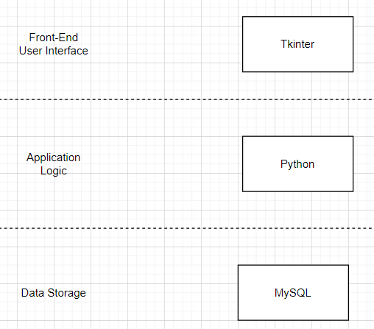

* User Interface Screens:

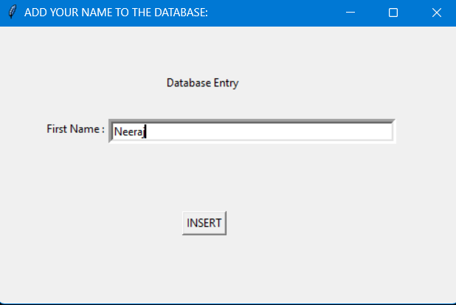

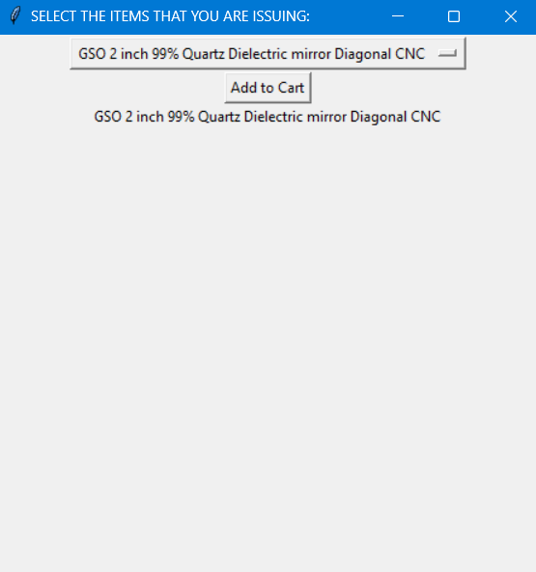

* Database Screens:

